Query->Sol-1 : SELECT ProductID,ProductName,UnitPrice FROM Products WHERE UnitPrice < 20

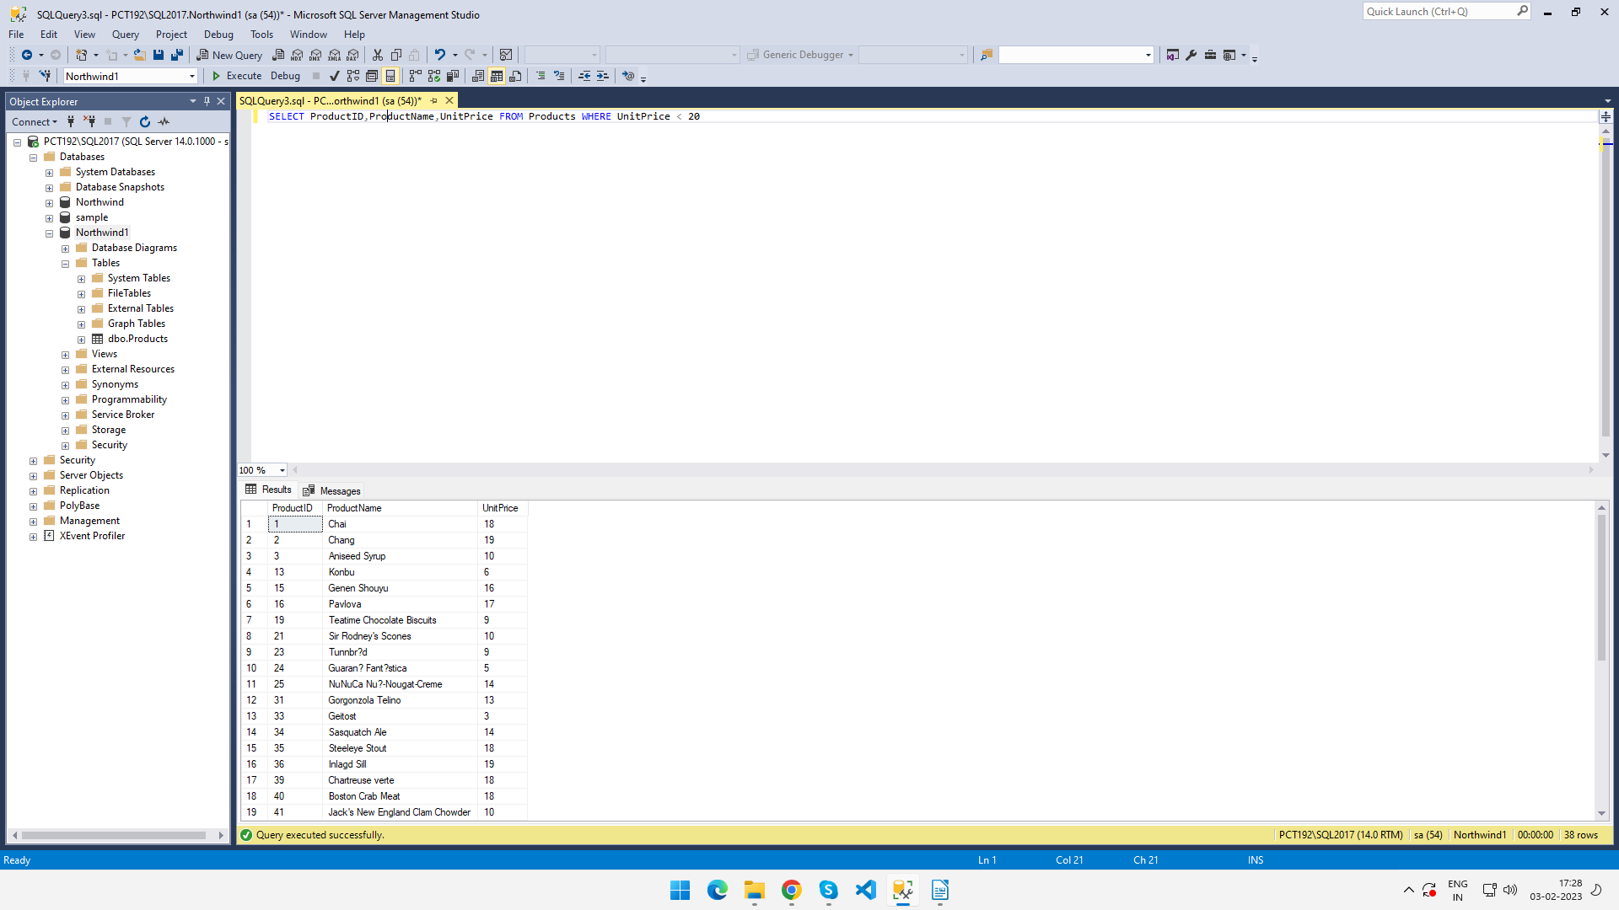

Query->Sol-2: SELECT ProductID,ProductName,UnitPrice FROM Products WHERE ( UnitPrice > 15 AND UnitPrice < 25)

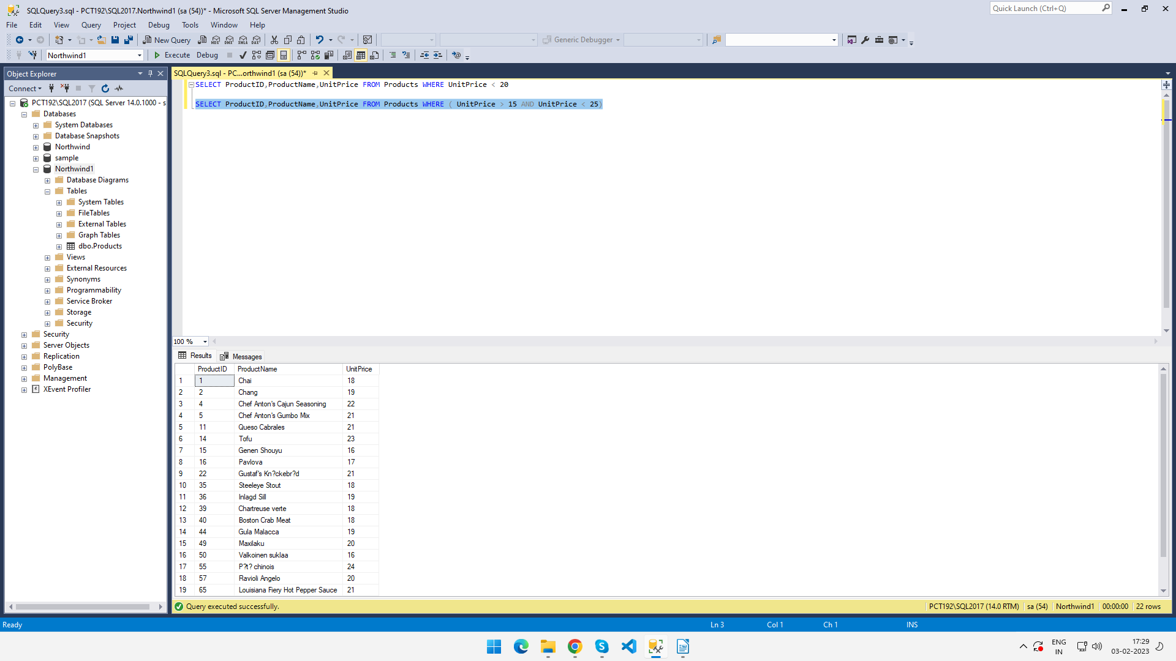

Query->Sol-3: SELECT ProductName,UnitPrice FROM Products WHERE UnitPrice > (SELECT AVG(UnitPrice) FROM Products)

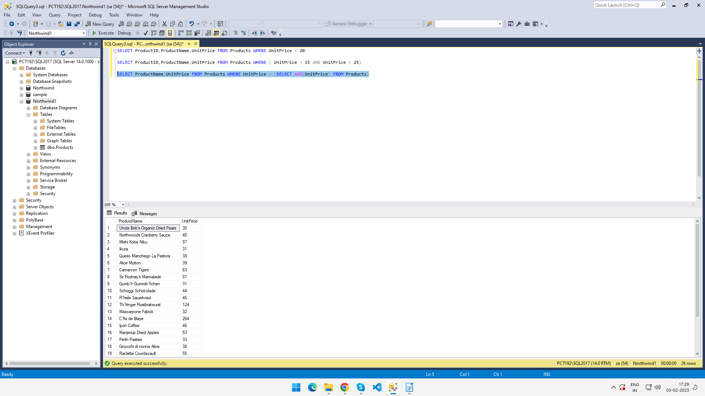

Query->Sol-4 : SELECT TOP 10 ProductName,UnitPrice FROM Products ORDER BY UnitPrice DESC

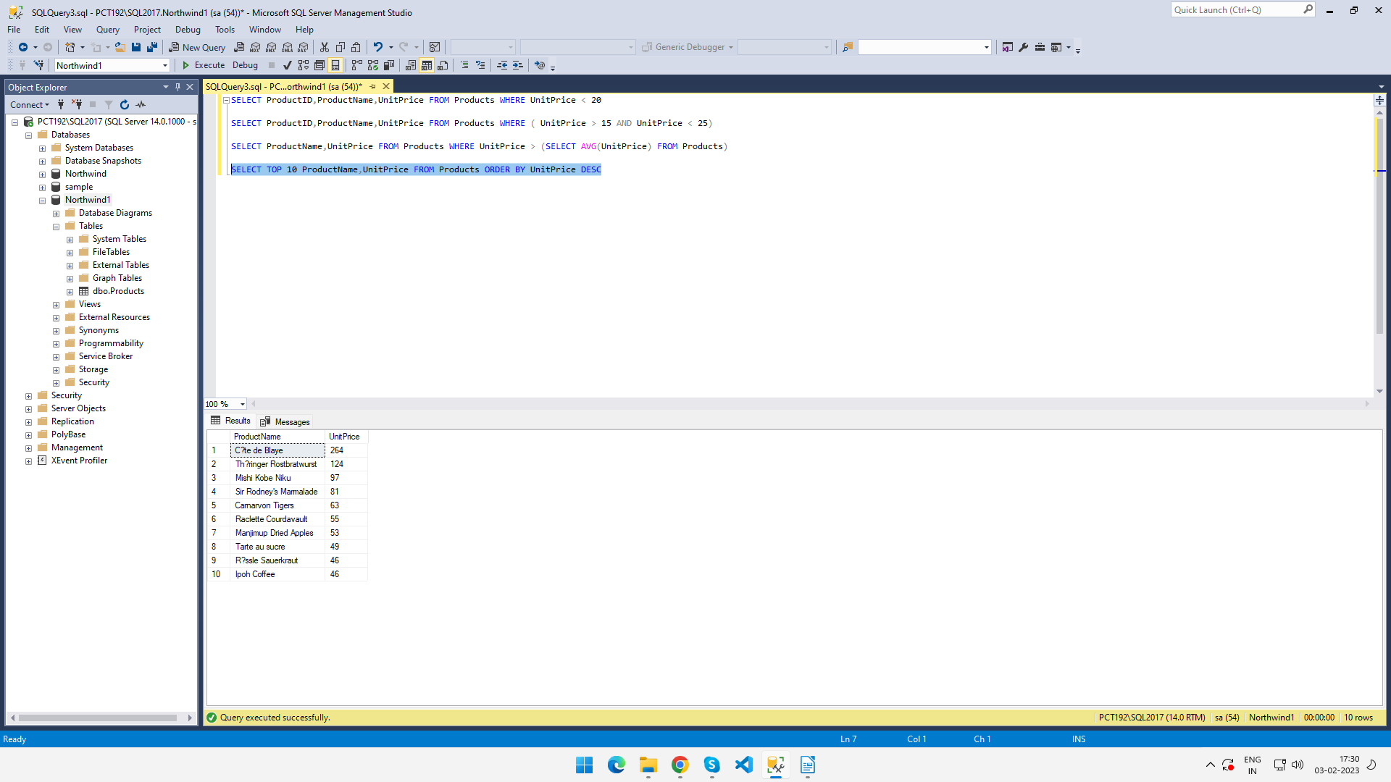

Query->Sol-5 : SELECT Discontinued, COUNT(\*) AS ItemCount FROM Products GROUP BY Discontinued

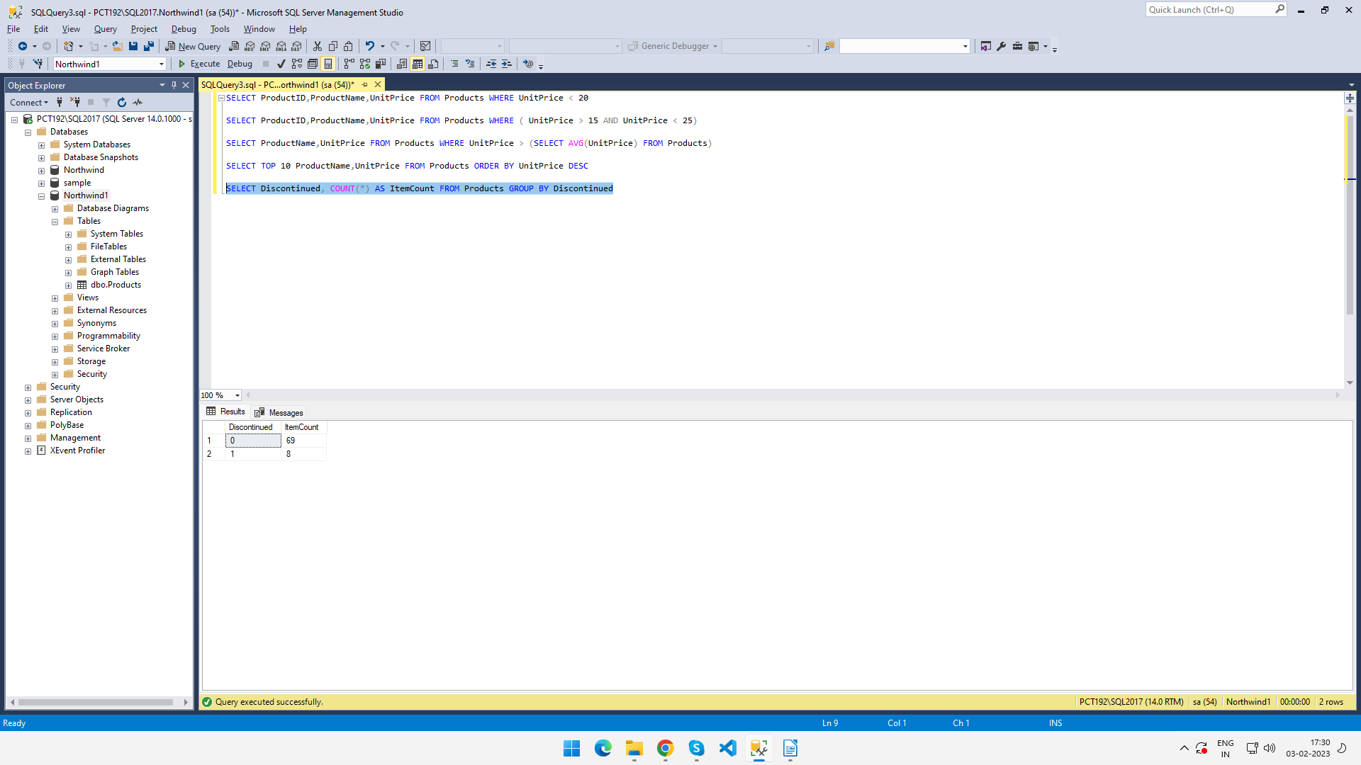

Query->Sol-6 : SELECT ProductName, UnitsOnOrder, UnitsInStock FROM Products WHERE (UnitsInStock < UnitsOnOrder)

